LAB 2

SUBJECT: OSG202

PROFESSOR: TONG PHUOC QUAN

STUDENT NAME/ID: NGUYEN MANH BAO TIN / SE170134

CLASS: SE1710

I. man command

- Syntax: man [OPTION…] [SECTION] PAGE…

- Functions: Shows the system’s reference manuals.

- Examples:

1. View the manual page for the man command:

|  |
| --- |
| man man |

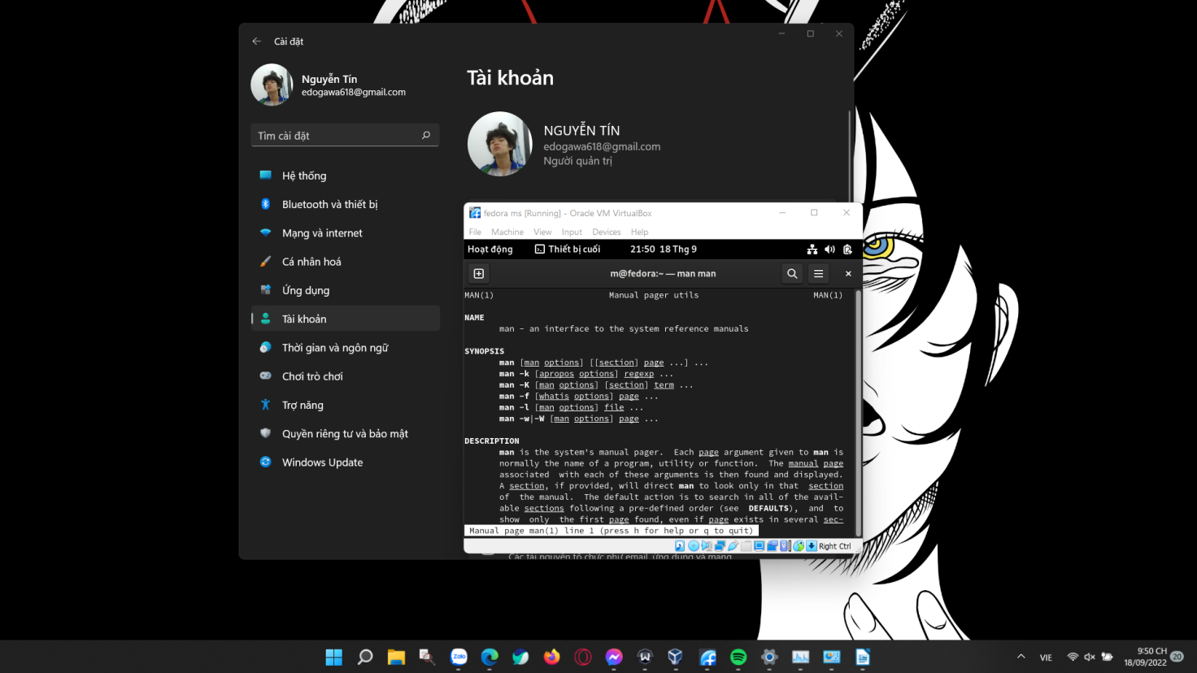

2. Display a short description of the kill command from the manual page:

|  |
| --- |
| man -f kill |

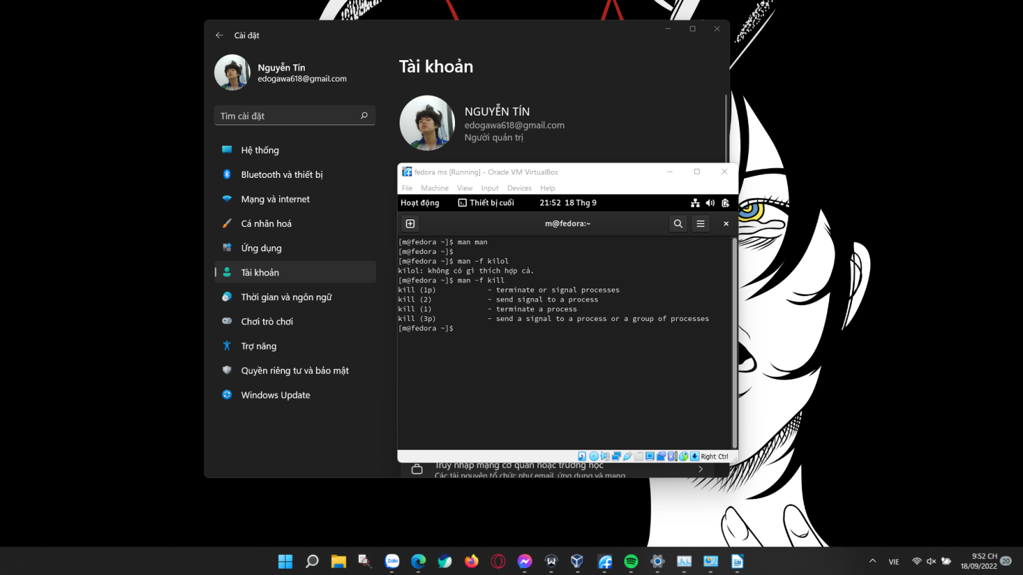

3. Job Control Commands: bg, fg

|  |
| --- |
| Syntax: bg [job] | fg [ %job] |

|  |
| --- |
| bg –help: view the manual page for the command bg |

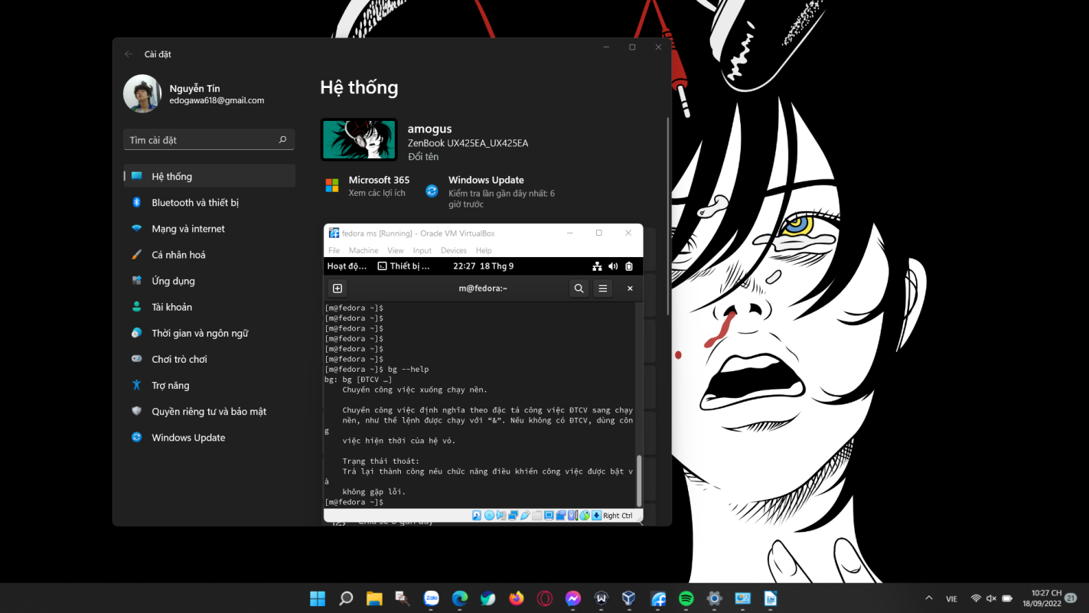

|  |
| --- |
| bg %n: Places the current or specified job in the background, where n is the job ID |

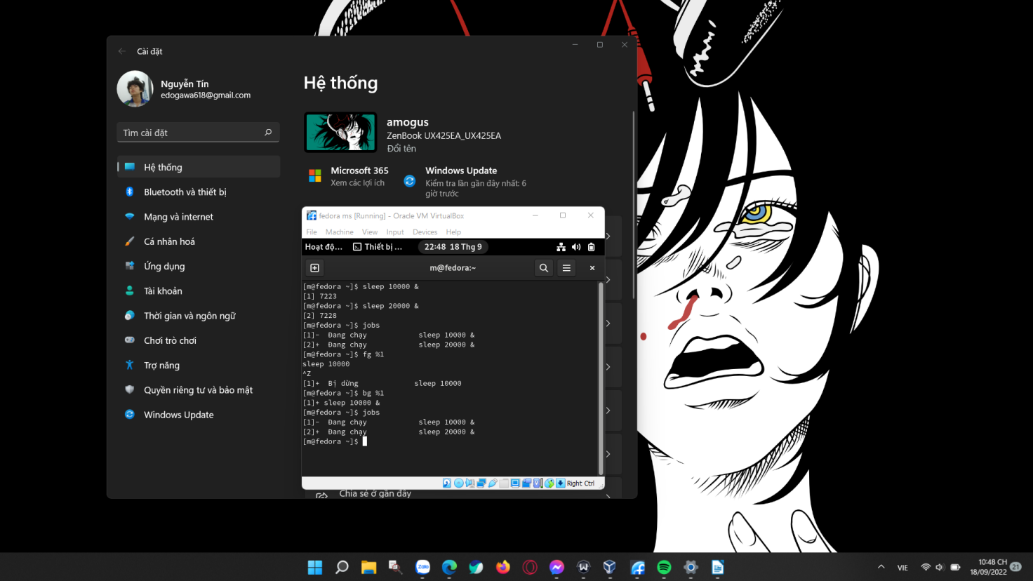

|  |
| --- |
| fg –help: view the manual page for the command fg |

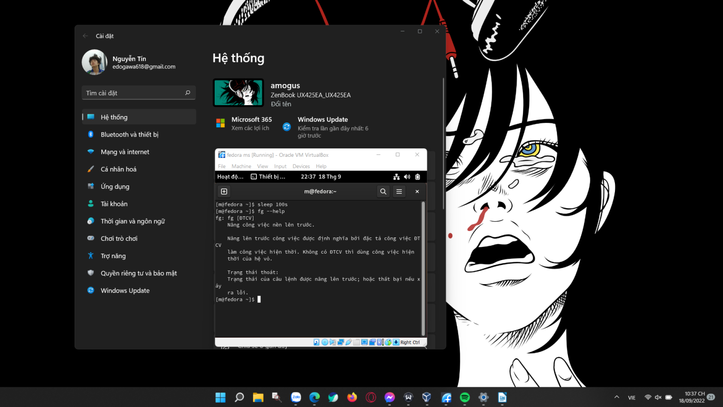

|  |
| --- |
| fg %n: Brings the current or specified job into the foreground, where n is the job ID |

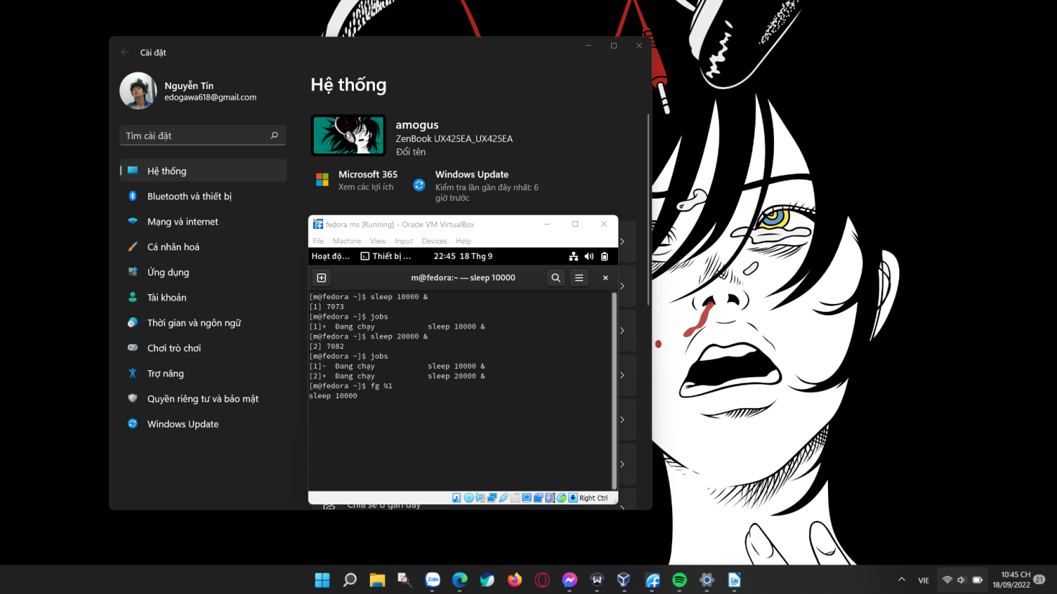

4. The Who command. Syntax: who [options] [filename]

|  |
| --- |
| who: Used to determine the details of users currently logged in to a system. The output of the who command includes the user name, the name of the system from which the user is connected, and the date and time that the user has been connected since. |

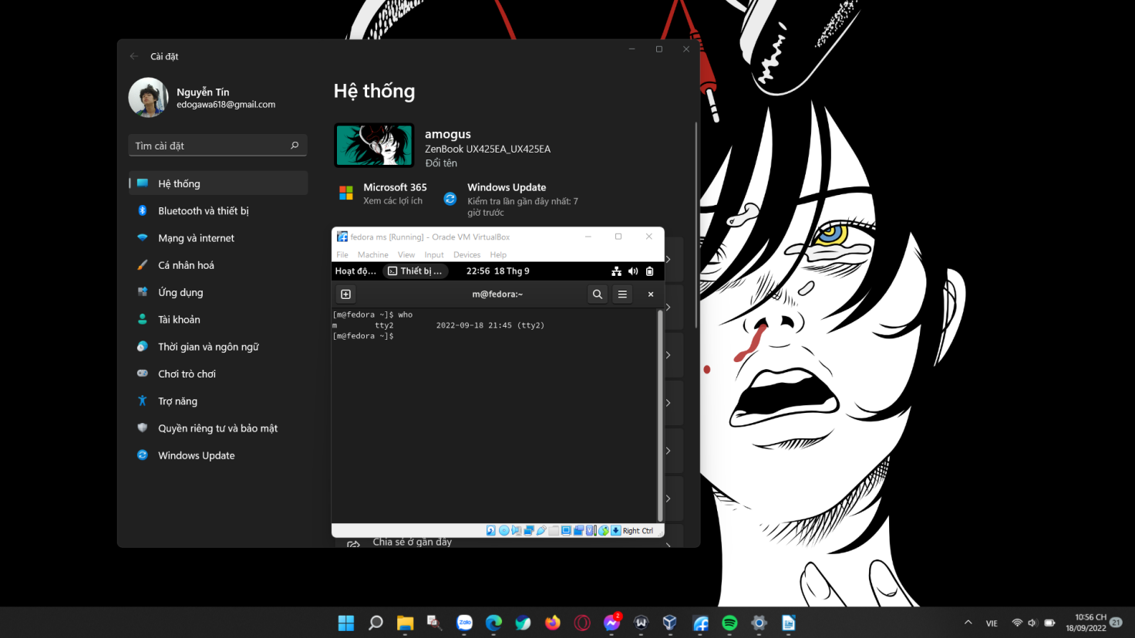

|  |
| --- |
| who -u: can be used to see how long users have been idle. A dot indicates that the users were active up to the last minute, old indicates that the users have been inactive for over 24 hours, and anything between 2 minutes and 23 hours 59 minutes shows the length of time they have been idle. |

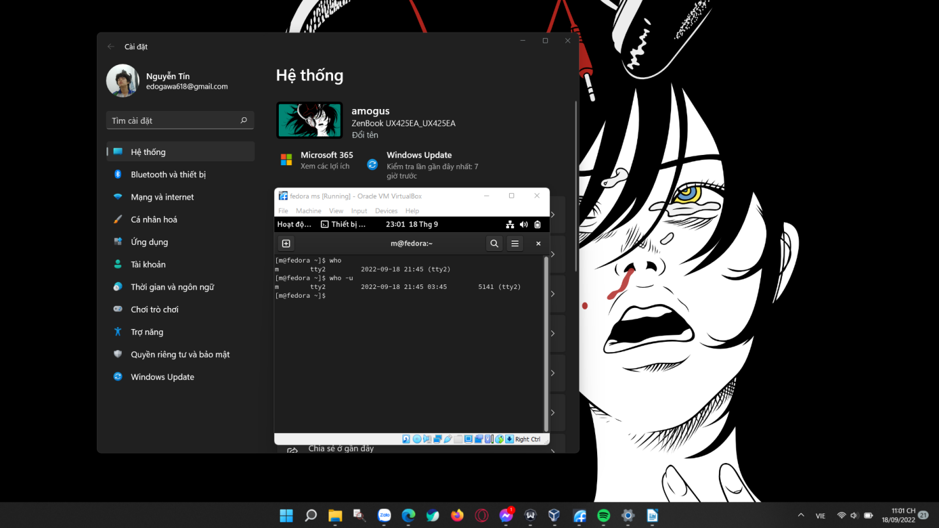

5. The chown command. Syntax: chown [OPTION]… [OWNER][:[GROUP]] FILE…

chown [OPTION]… –reference=RFILE FILE…

|  |
| --- |
| chown: Used to change the owner, the group, or both for a file or directory. At times, you may wish for someone else to manage an object’s permissions other than the user who created that object. |

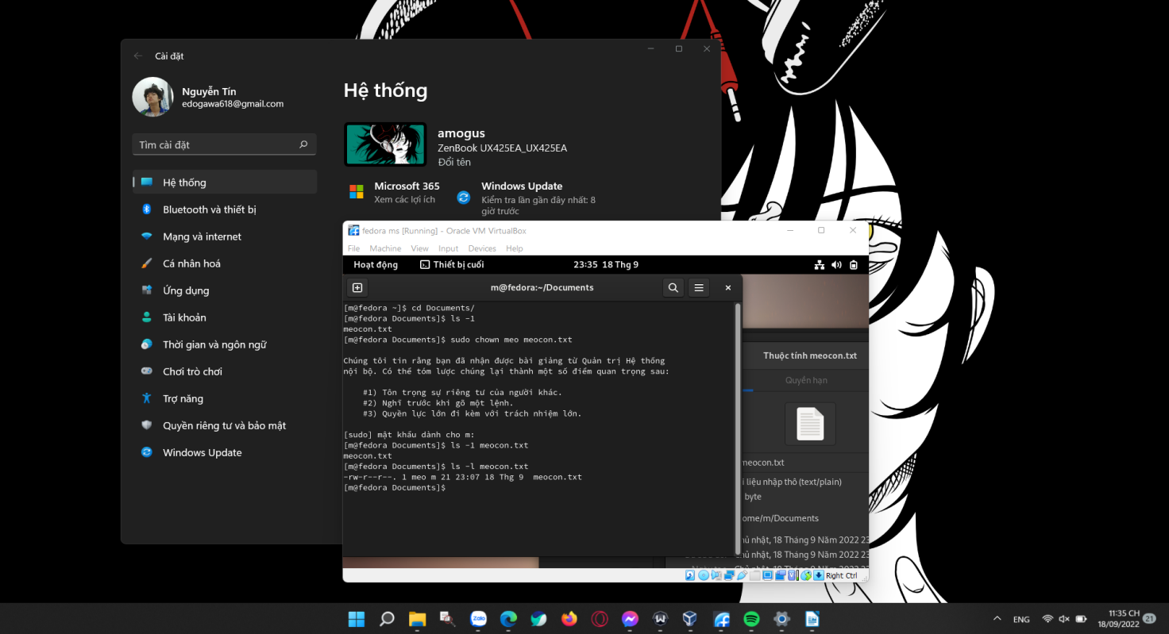

|  |
| --- |
| chown –help: view the manual page for the command chown |

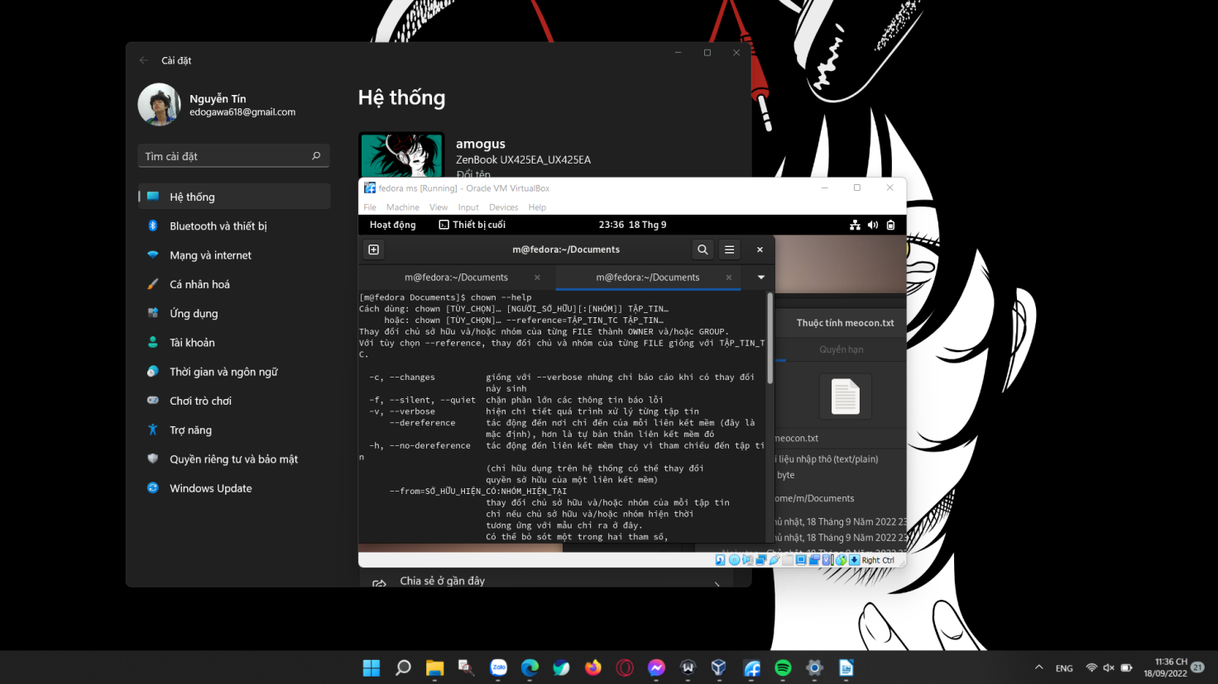

6. chgrp command. Syntax: chgrp [OPTION]… GROUP FILE…

chgrp [OPTION]… –reference=RFILE FILE…

|  |
| --- |
| chgrp: used to change the group ownership of a file or directory. |

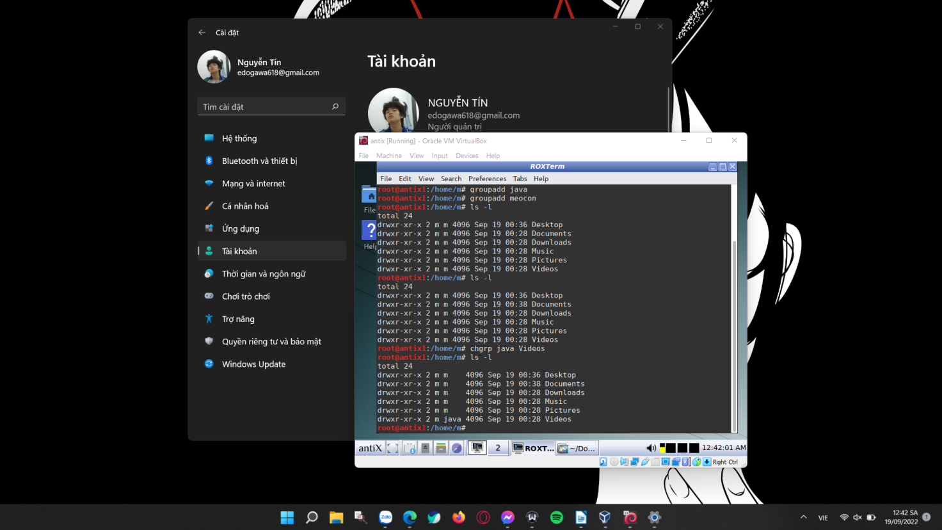

|  |
| --- |
| chgrp –help: to show the manual page of the command chgrp |

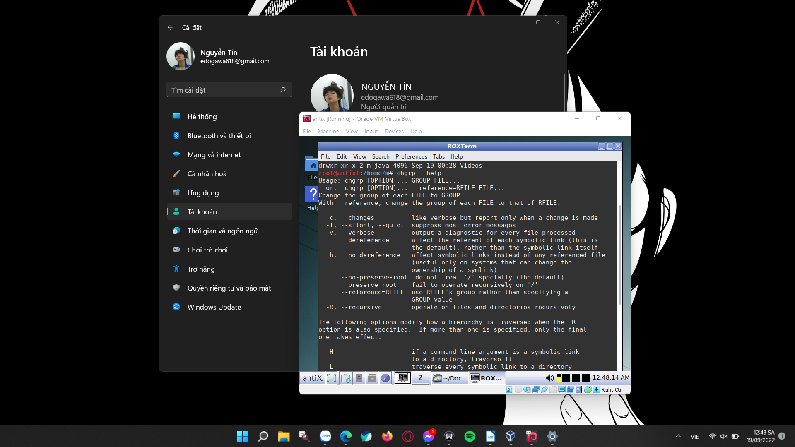

7. the chmod command is used to change permissions on a file or directory is chmod, which we like to read as change file mode. Syntax: chmod <options> <permissions> <file name> .

|  |
| --- |
| chmod 644 <filename>: give Read & Write permission to User/Owner and Read permission to Group & Others using Numeric way. |

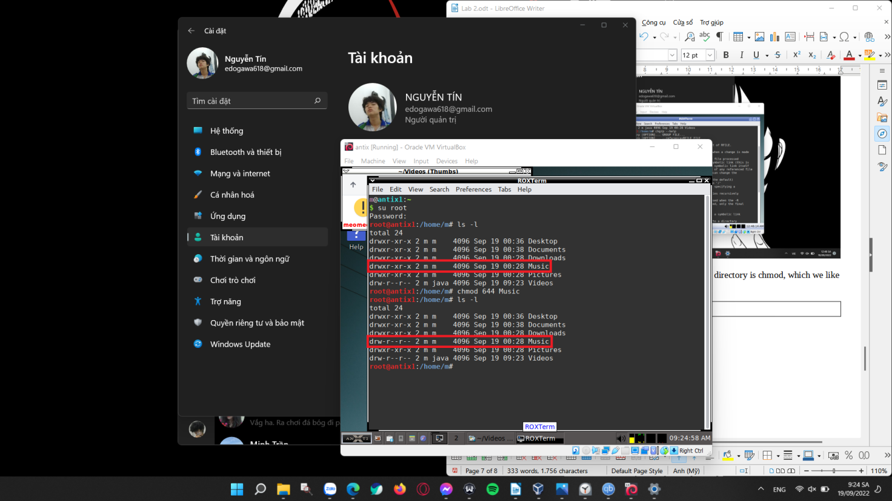

|  |
| --- |
| Chmod u-rw <filename>: Remove permission from a file/directory using below Linux chmod command. Here I am removing Read and Write permission from User/Owner. |

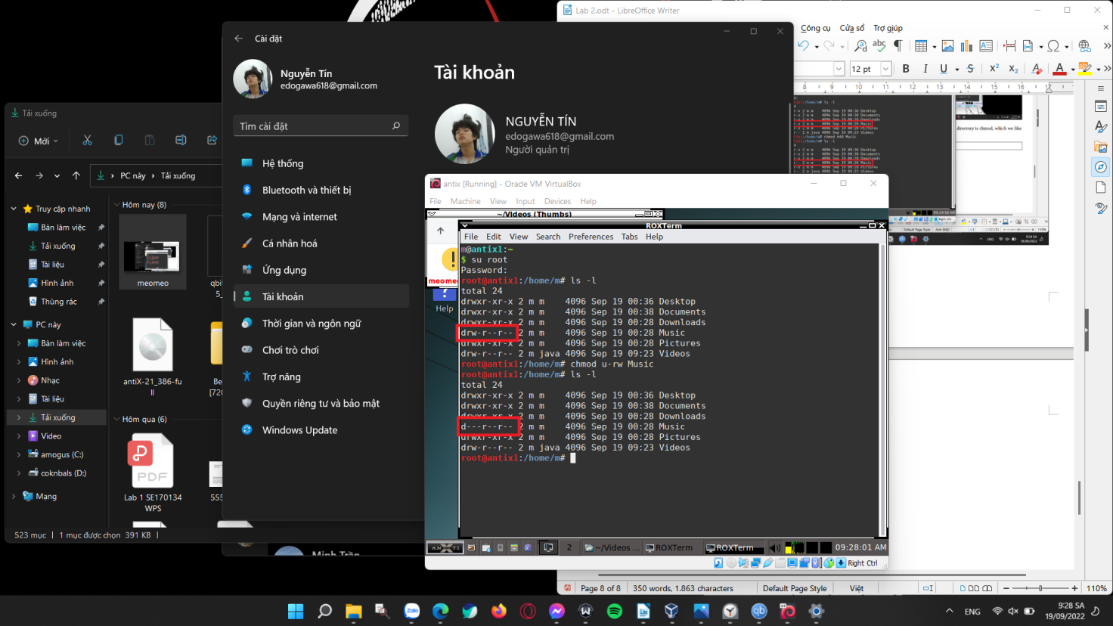

8. The date command.

The date command is used to print the date in a specified format. The date command will print the date based on the /etc/localtime file. By default, it will print the date in the following format:

[day of week] [month] [day] [24 hour time ##:##:##] [time zone] [year]

Wed Oct 31 15:03:16 GMT 2018

The syntax of the date command is: date <option> <format>

Formatting options shown in the following table:

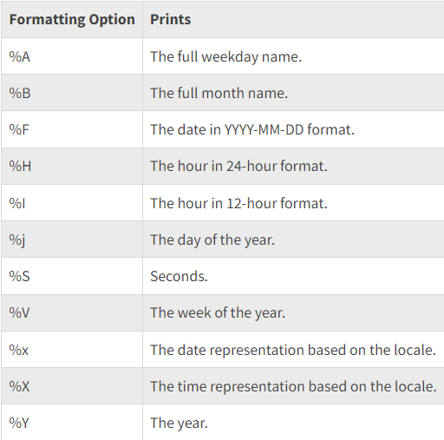

Examples:

|  |
| --- |
| date: to display the date and the time |

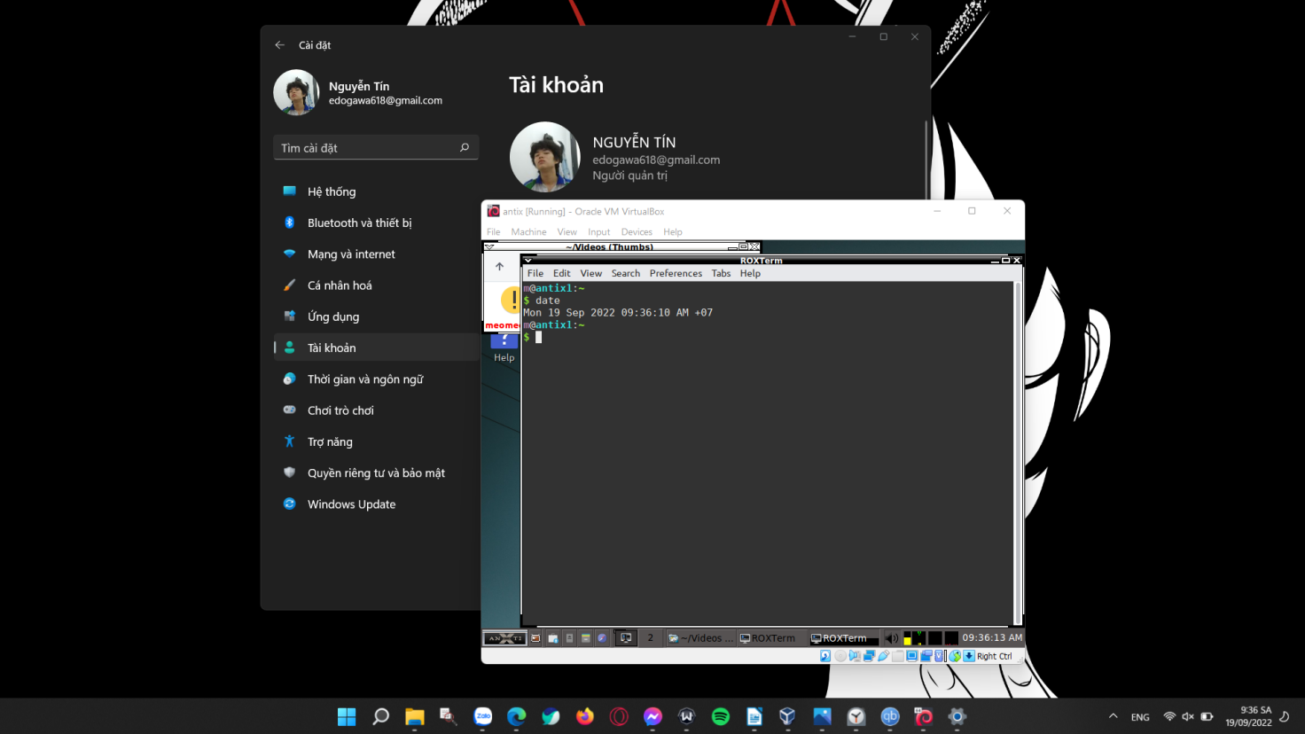

|  |
| --- |
| date -u  date –utc → to show the time specified by the time format  date --universal |

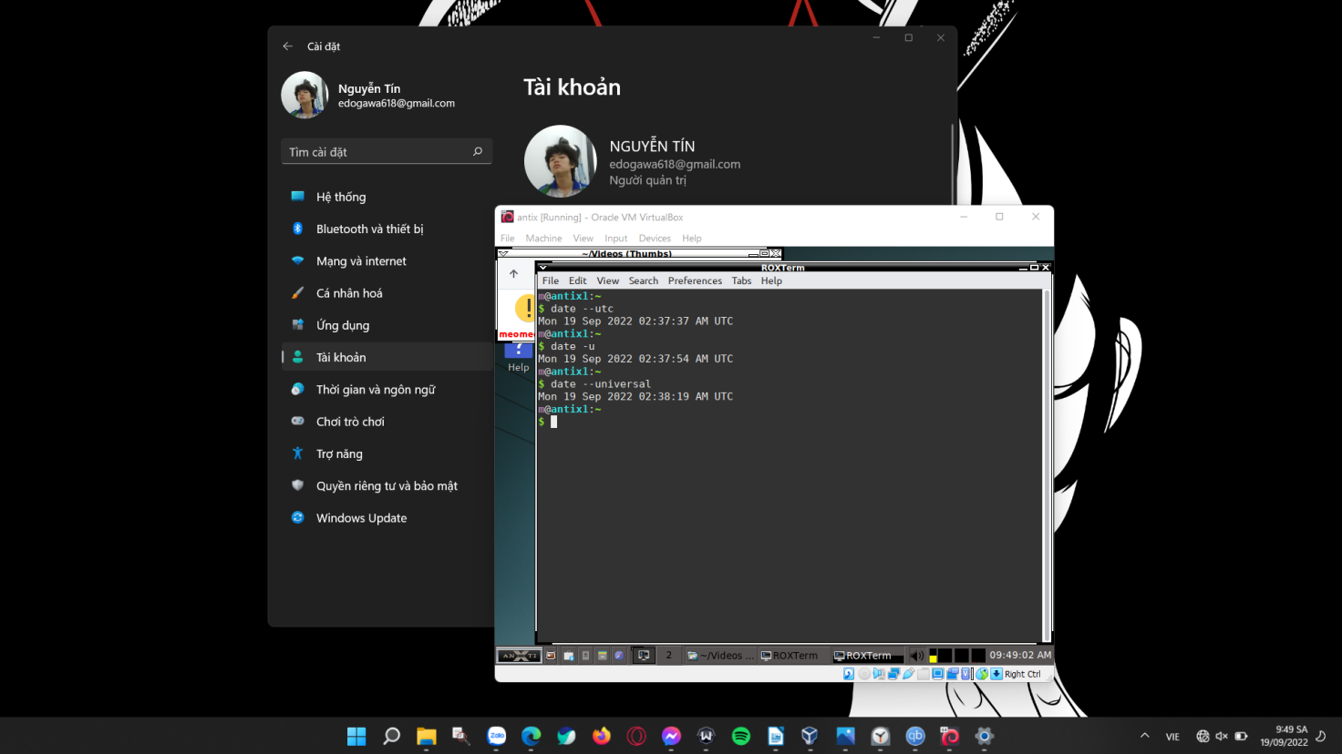

9. The su command:

The syntax of the su command is: su [options] [username [arguments]]

If a username is specified, su defaults to the superuser (root). Simply find the user you need and add it to the su command syntax.

The su command is used to run a function as a different user. It is the easiest way to switch or change to the administrative account in the current logged in session.

Some versions of Linux, like Ubuntu, disable the root user account by default making the system more secure. But, this also restricts the user from running specific commands.

Using su to temporarily act as a root user allows you to bypass this restriction and perform different tasks with different users.

Examples:

|  |
| --- |
| su <other_user>: to switch the logged-in user in this terminal window, you’ll be asked for the other user account’s password. |

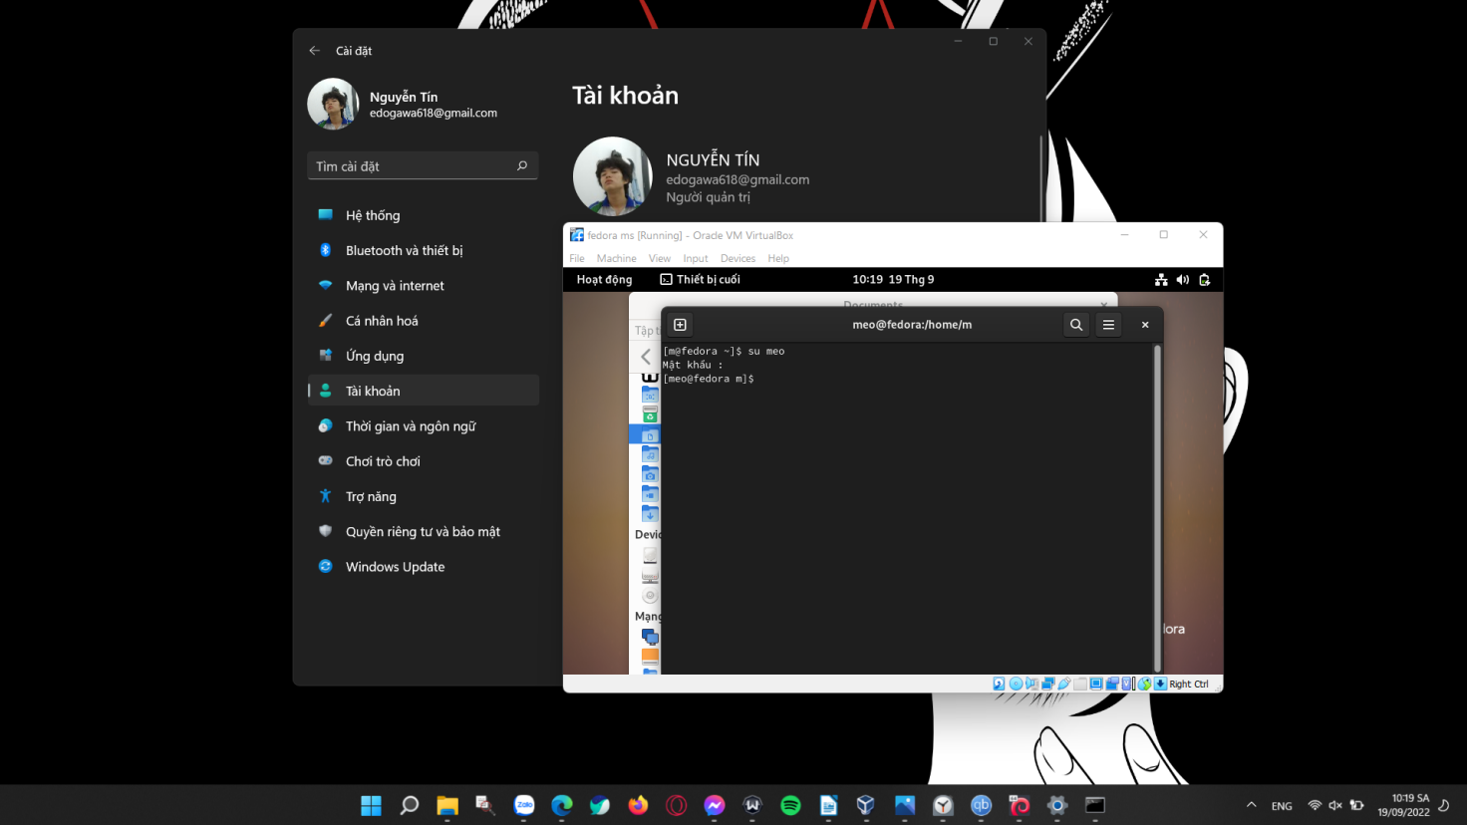

|  |
| --- |
| su <other user> -c <command> : to execute a command under another user’s authority. |

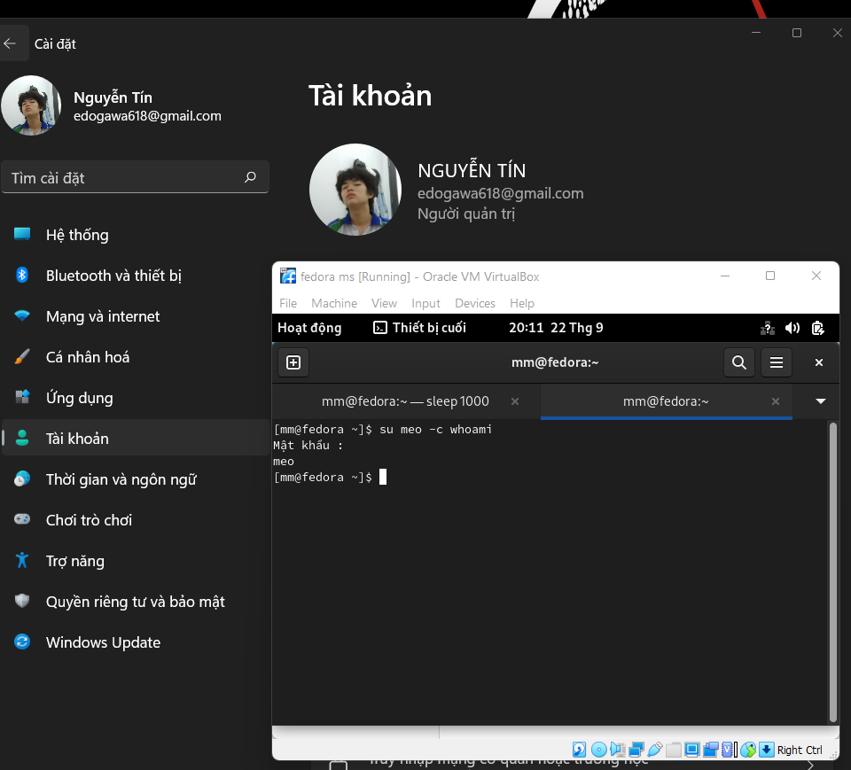

10. The top command:

Here below is the top command syntax with all the available options and flags:

|  |
| --- |
| top -hv | -bcEeHiOSs1 -d secs -n max -u | U user -p pid(s) -o field -w [cols] |

The top (table of processes) command shows a real-time view of running processes in Linux and displays kernel-managed tasks. The command also provides a system information summary that shows resource utilization, including CPU and memory usage.

Examples:

|  |
| --- |
| top -d <seconds.tenths>: It tells delay time between screen updates. |

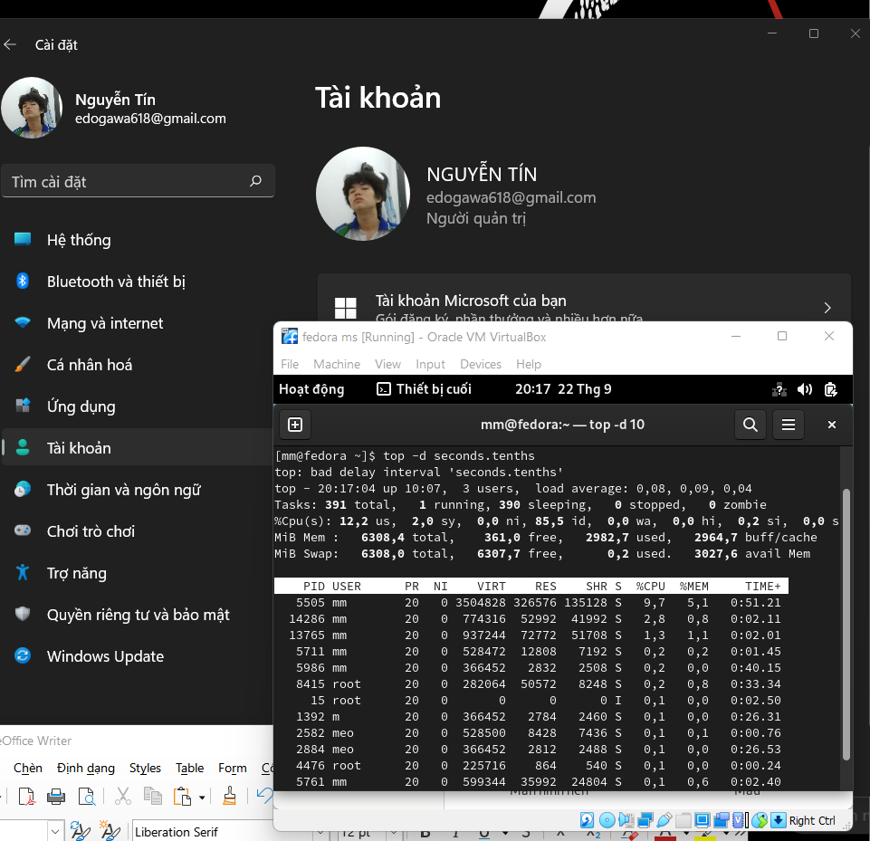

|  |
| --- |
| top -<user> paras: Display Specific User Process |

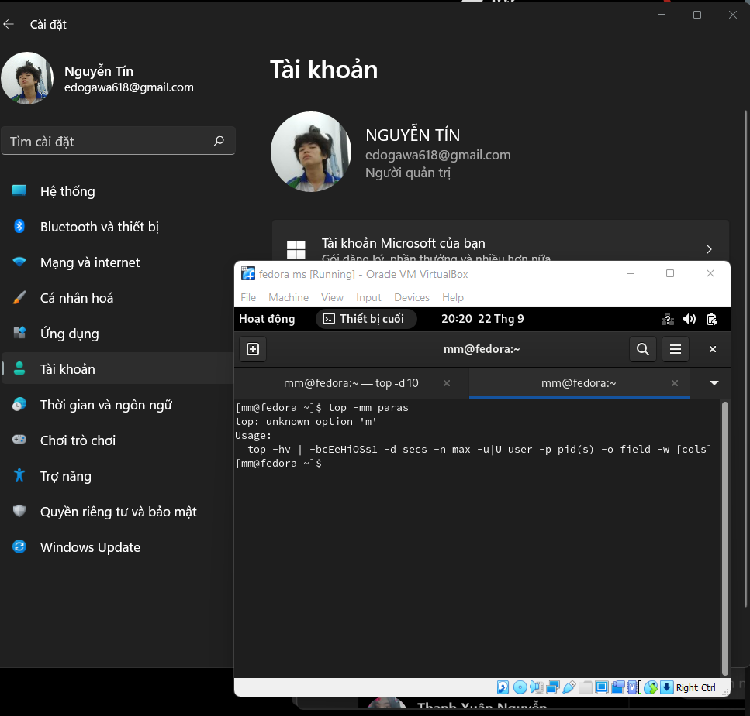

1. The kill command:

Syntax:

|  |
| --- |
| kill <OPTIONS> <PID> |

kill command in Linux (located in /bin/kill), is a built-in command which is used to terminate processes manually. kill command sends a signal to a process which terminates the process. If the user doesn’t specify any signal which is to be sent along with kill command then default TERM signal is sent that terminates the process.

Examples:

|  |
| --- |
| kill -l: To display all the available signals you can use below command option. |

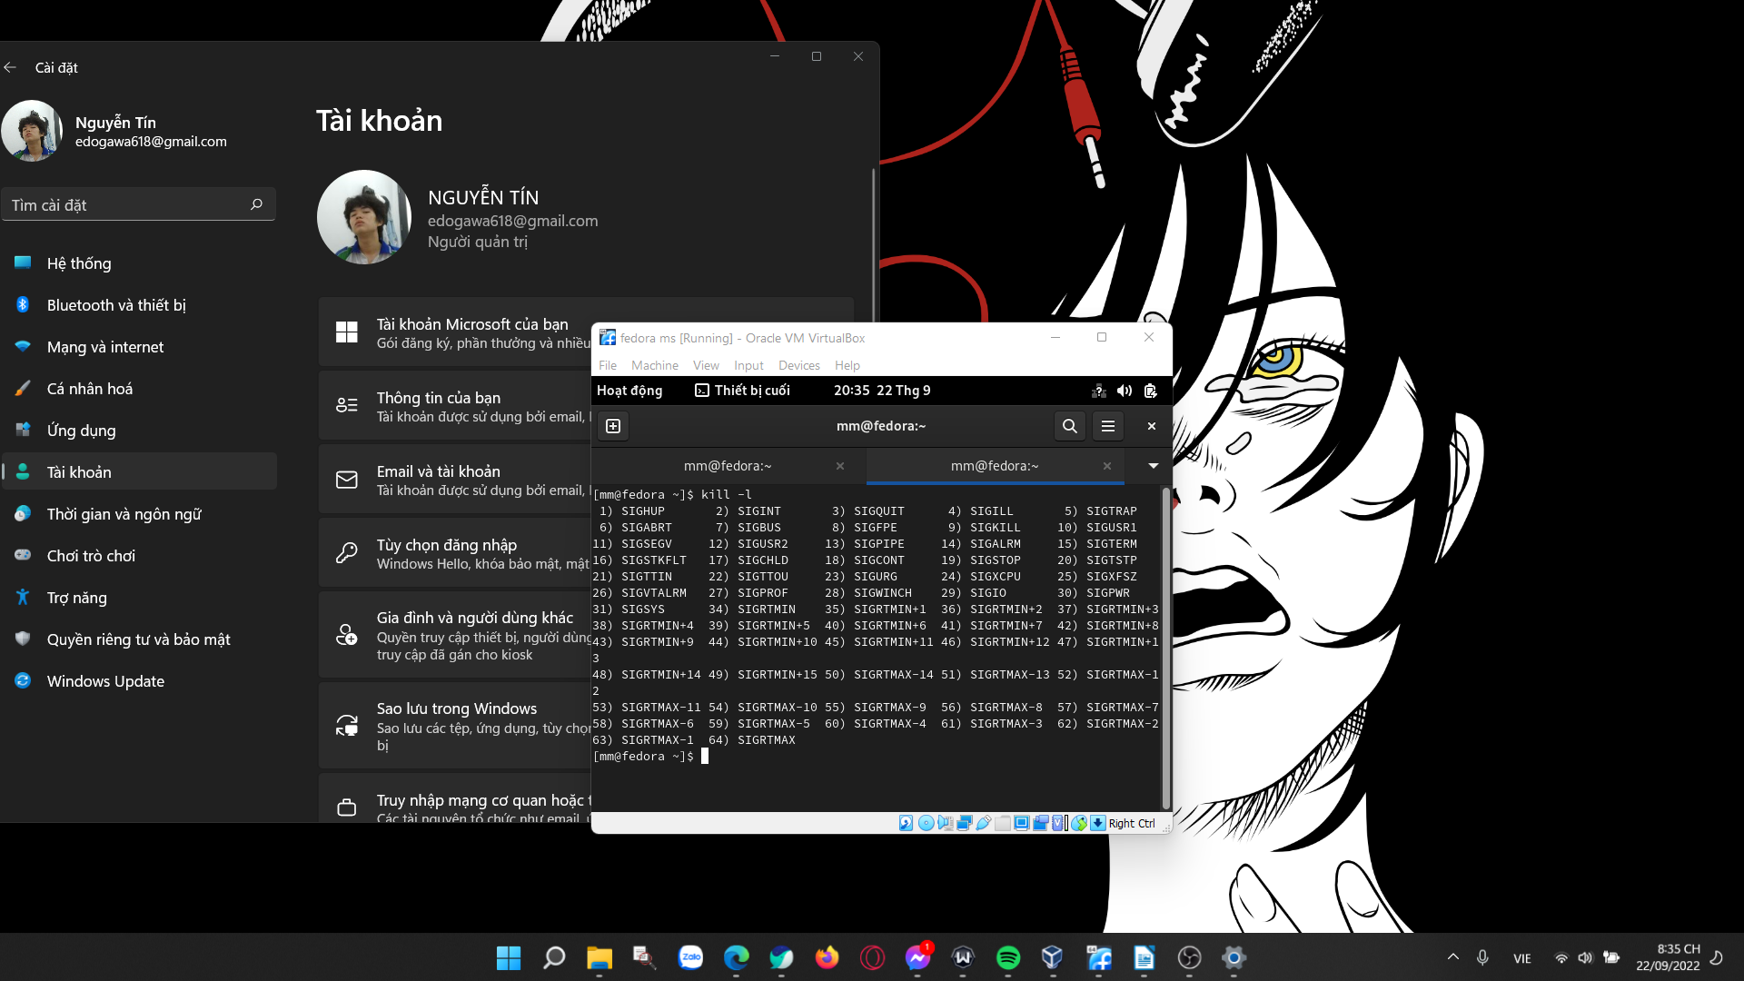

|  |
| --- |
| kill -L: This command is used to list available signals in a table format. |

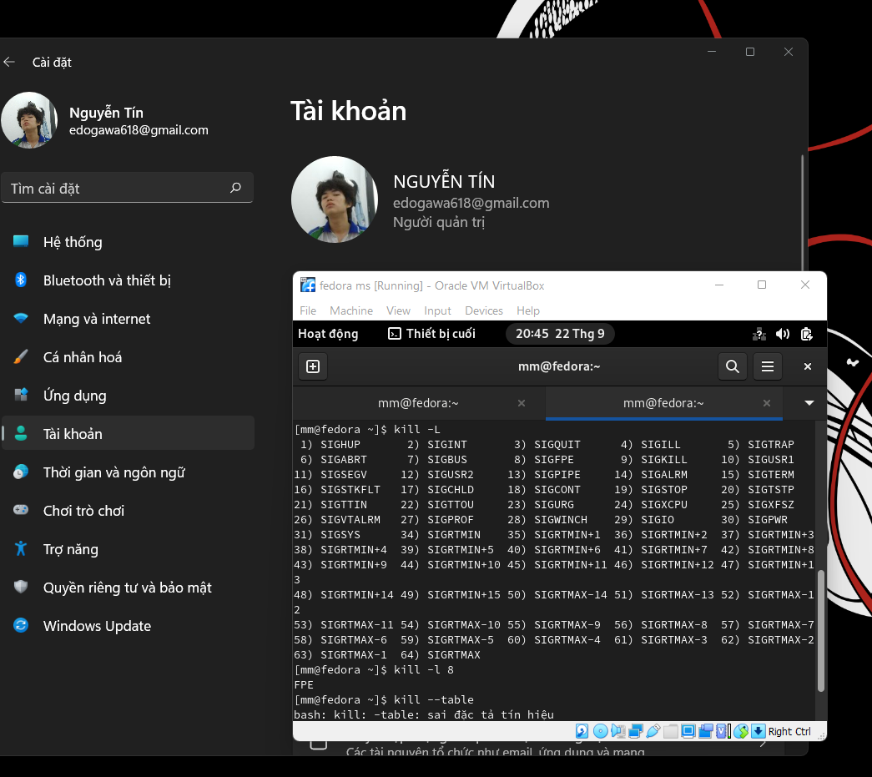

12. The jobs command

Syntax:

|  |
| --- |
| jobs [JOB] |

Jobs command is used to list the jobs that you are running in the background and in the foreground. If the prompt is returned with no information no jobs are present. All shells are not capable of running this command. This command is only available in the csh, bash, tcsh, and ksh shells.

Examples:

|  |
| --- |
| jobs: To display the status of jobs in the current shell: |

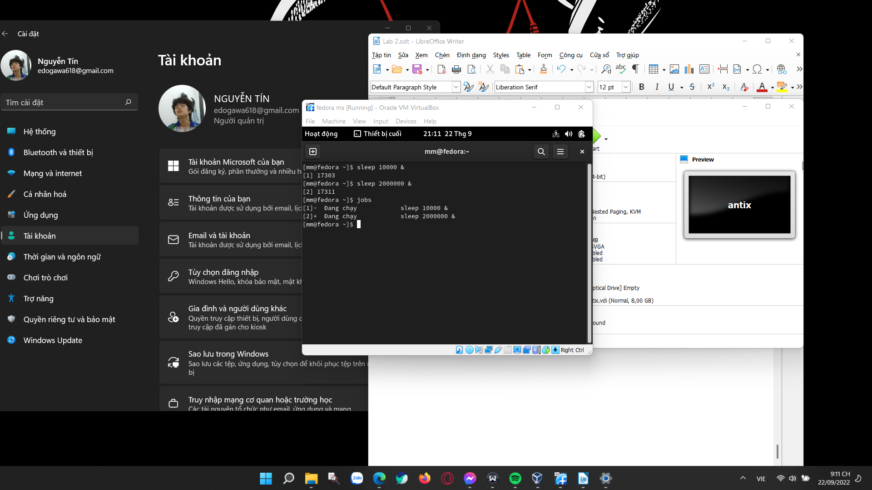

|  |
| --- |
| jobs -r: Display only running jobs |

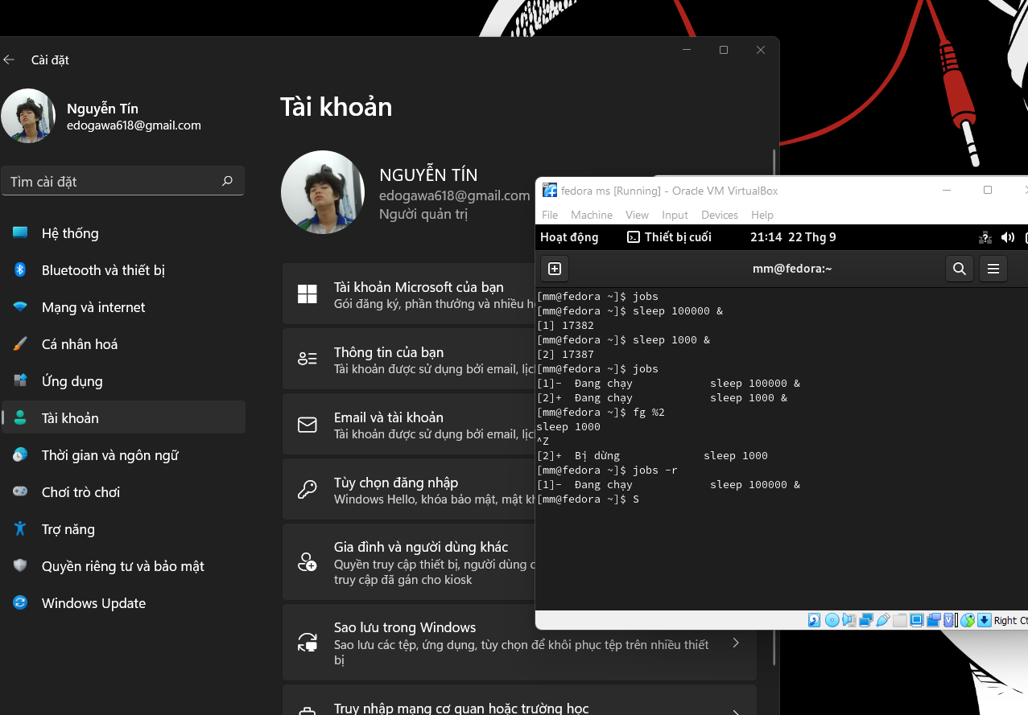

13. Using the “grep “nhu nui” thoca.txt”

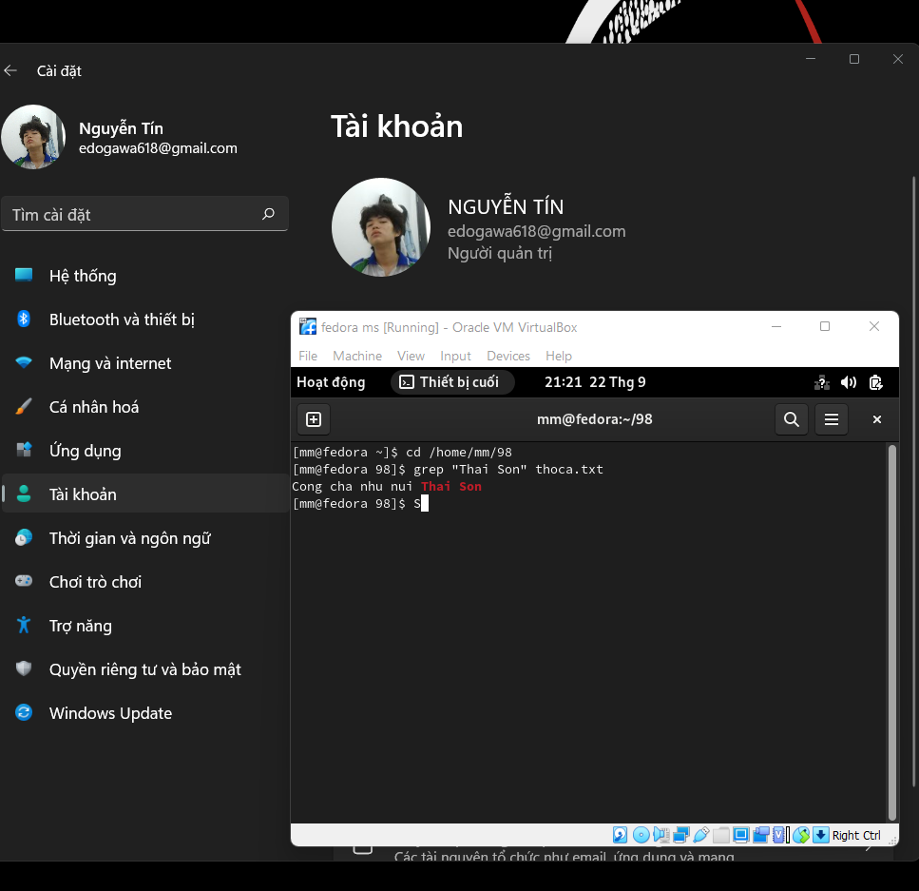

The grep command prints out the line in a text file that matches a given pattern. The file and pattern in this case are thoca.txt and "thai son." After executing the grep command, it went through the content in thoca.txt line by line, looking for lines that contained the string "thai son." Finally, it printed the result, which is the line "cong cha nhu nui thai son" with the word "thai son" highlighted in red.

14. Submit the C/C++ files and objects files as the below content then capture the result of the program and explaination your result that you get

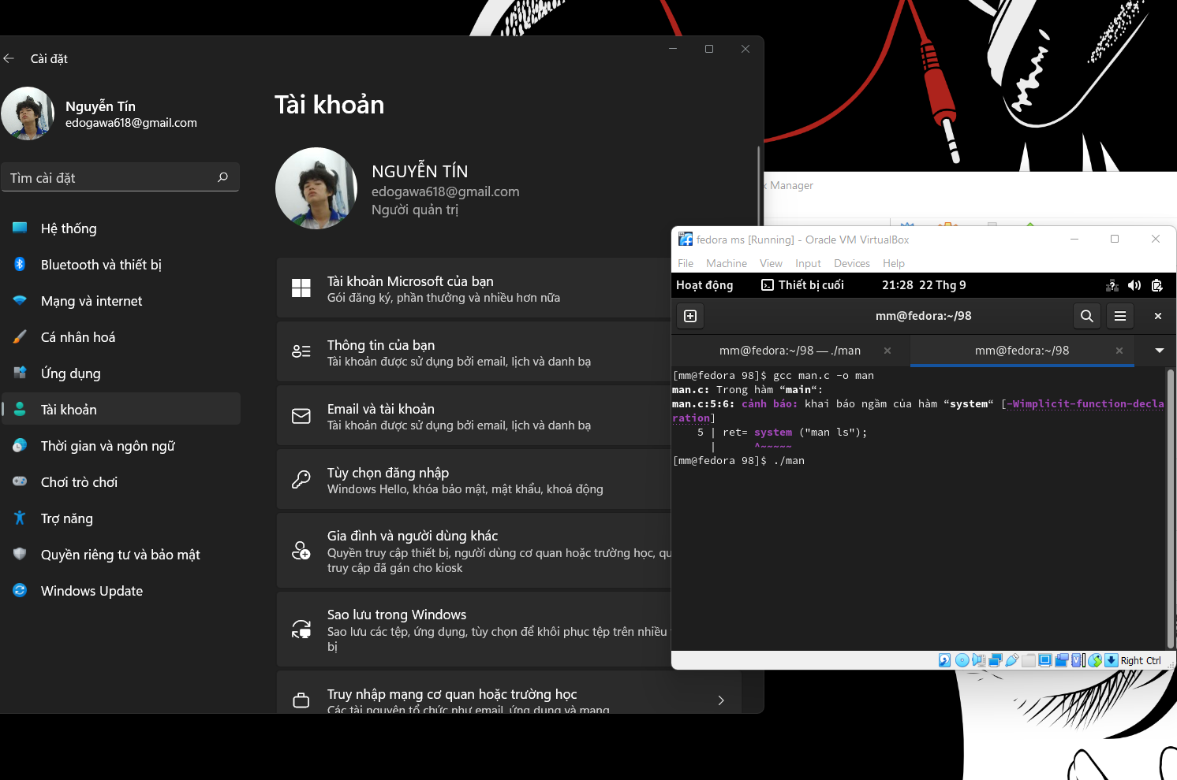

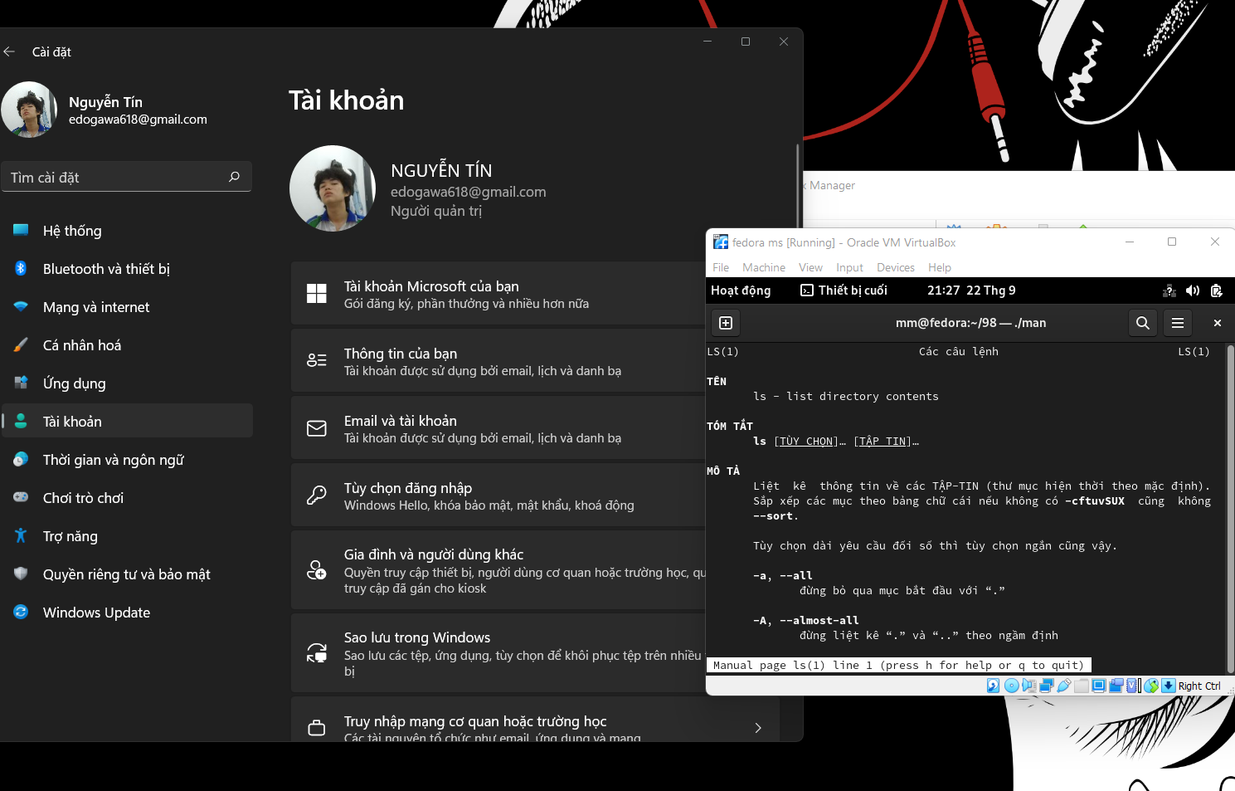

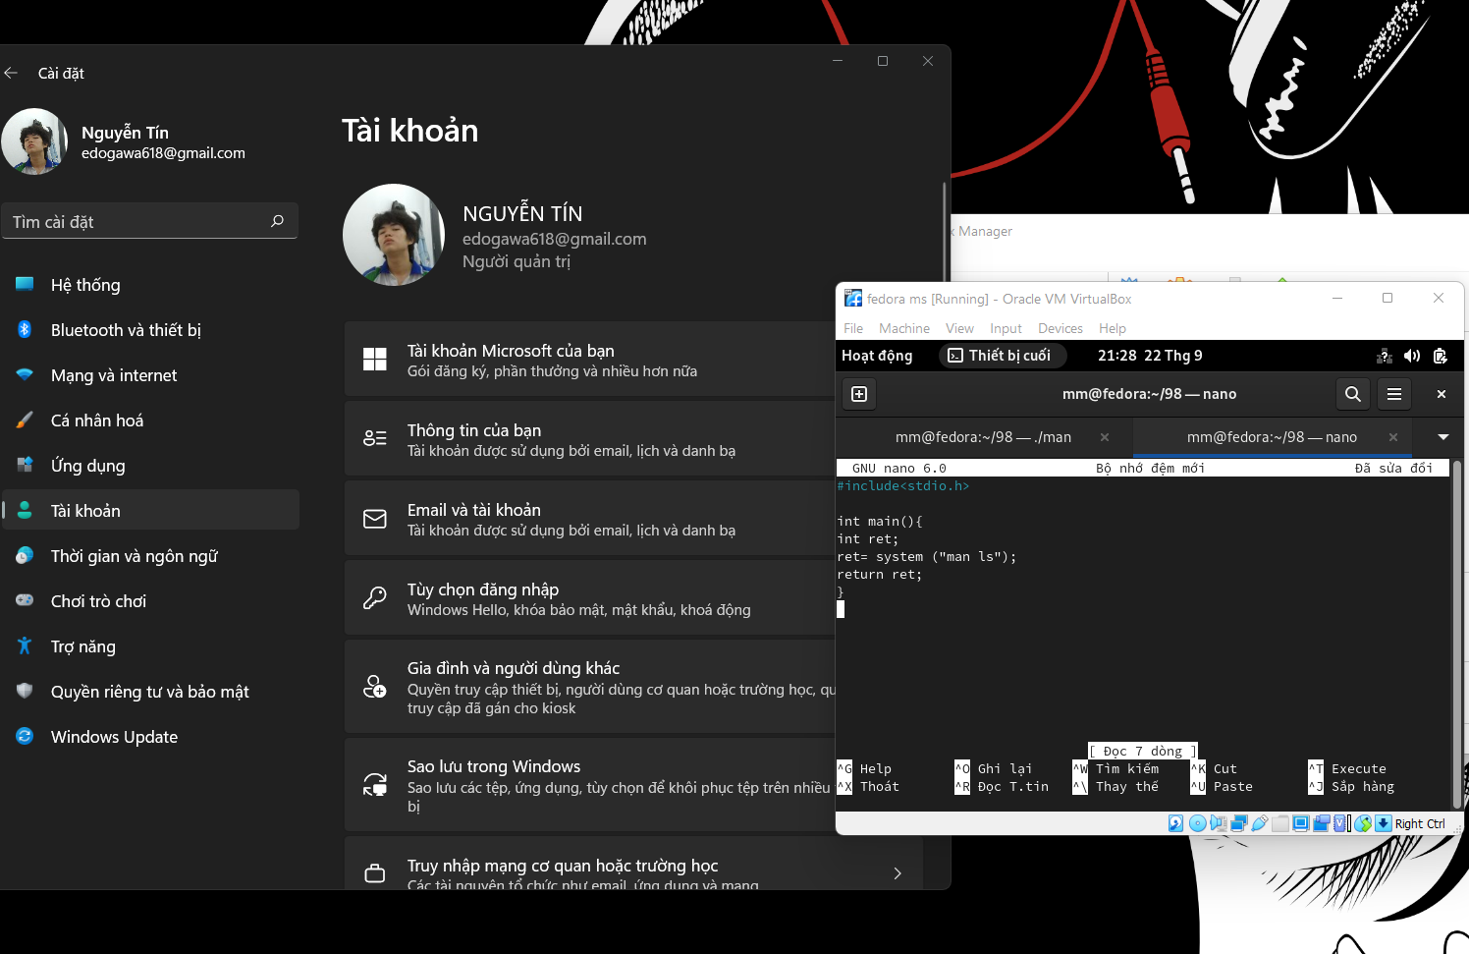

In C, the system() function is used to provide commands that can be performed in the operating system's command processor or terminal. The command is then executed, and the status of the command is returned, or -1 if there is a problem. In this scenario, we supplied the man ls command to the system() method. The computer then conducted the command and produced the manual page of the ls command in the output. Following that, the system() function reported the status of the performed command, which was 0 for success. The ret variable then held the return value of the system() function. Finally, the program returned the value of variable ret, which was 0. The program completed correctly and exited.

Sources: [Javapoint](http://www.javatpoint.com/), [Geeks4Geeks](http://www.geeksforgeeks.org/).